

WORKDESK

USER MANUAL

Workdesk is a tool, which helps to manage and configure applications. Admin tab on the left side bar helps to configure applications.

# Admin tab forms

* Configurations
* Logos
* Applications
* Workdesks
* Links
* Roles
* Role Members

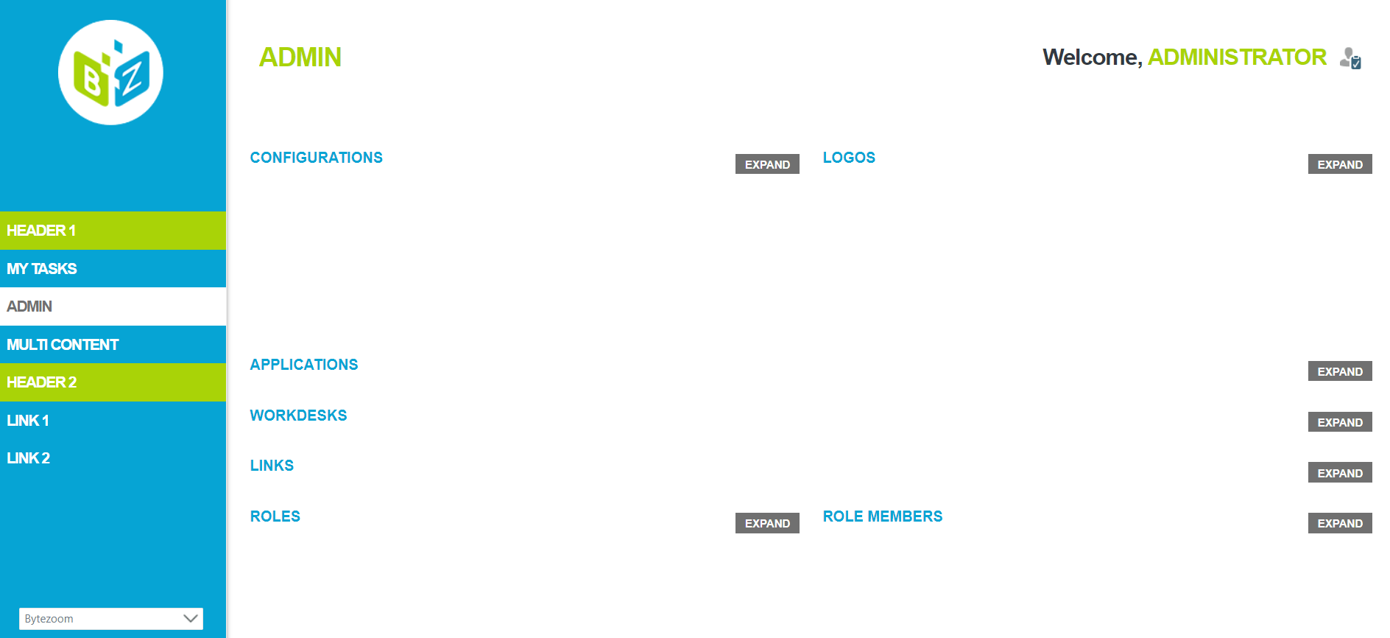

## Configurations

This form helps to configure color of the text, background, borders etc.

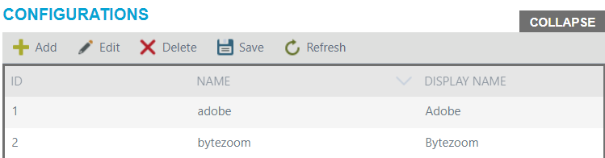

Buttons:

* Add
* Edit
* Delete
* Save
* Refresh

To add configurations click Add button. Add button opens a panel, where you should enter workdesk config. After adding, click Add button on panel and Save button on Configurations form. To cancel changes click on Cancel button on panel.

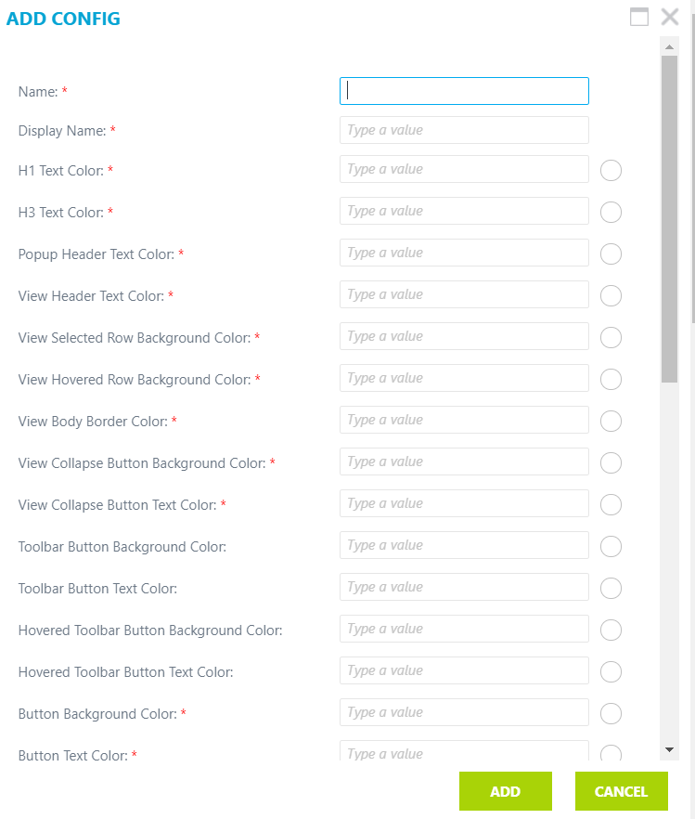

To modify configurations click on the Edit button. Edit button opens a panel, where you should reenter configurations. After changes, click Edit button on the panel and on Save button on the form. To cancel changes click on Cancel button on panel.

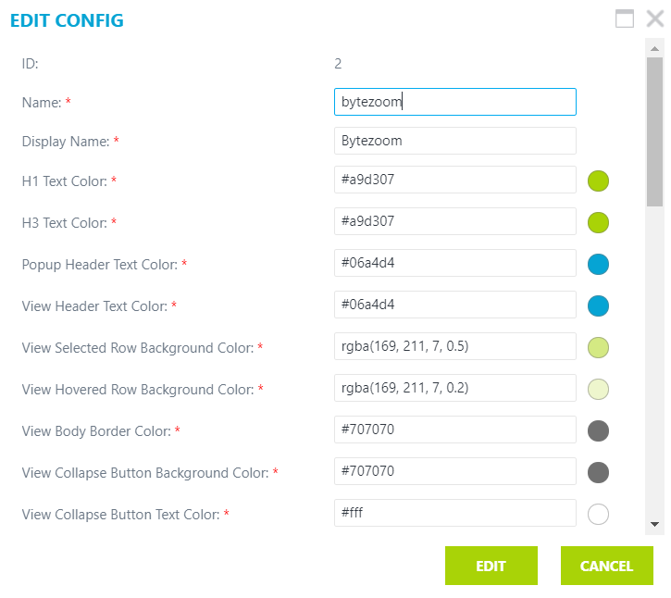

To delete, click on the name you are interested in and click the Delete button. To refresh the list, click Refresh.

## Logos

This form for adding logos.

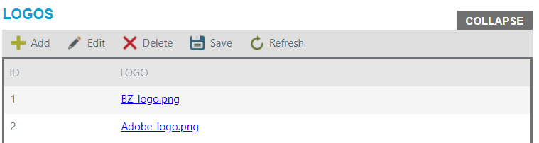

Buttons:

* Add
* Edit
* Delete
* Save
* Refresh

To add new logo of your workdesk click Add button. Add button opens a panel, where you should attach file. After adding, click Add button on panel and Save button on Logos form. To cancel changes click Cancel button on panel.

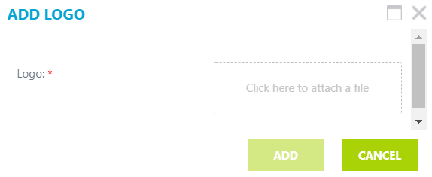

To modify logo click on logo you interested in and click Edit button. Edit button opens a panel, where you should click on X and add new logo file. After changes, click Edit button on the panel and Save button on the form. To cancel changes click Cancel button on panel.

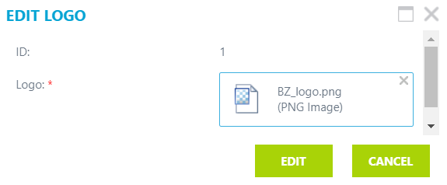

To delete, click on the logo you are interested in and click the Delete button. To refresh the list, click Refresh.

## Applications

This form is for adding applications.

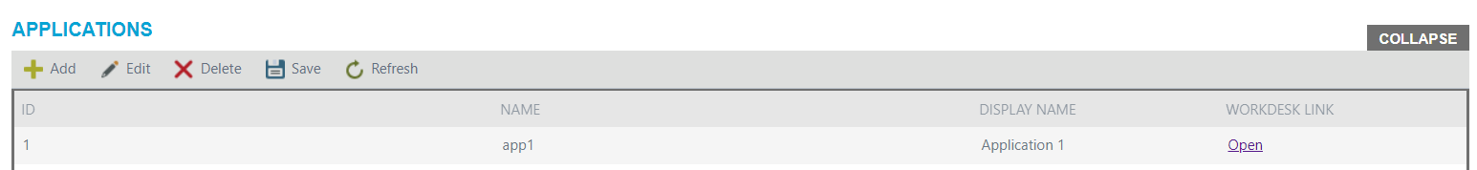

Buttons:

* Add
* Edit
* Delete
* Save
* Refresh

To add new application click Add button. Add button opens a panel, where you should enter the name of application. After adding, click Add button on panel and Save button on Logos form. To cancel changes click Cancel button on panel.

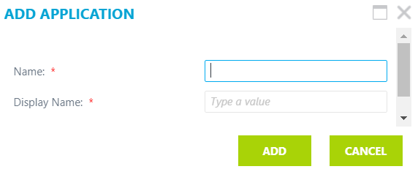

To modify application`s name click on application you are interested in and click Edit button. Edit button opens a panel, where you should change names. After changes, click Edit button on the panel and Save button on the form. To cancel changes click Cancel button on panel.

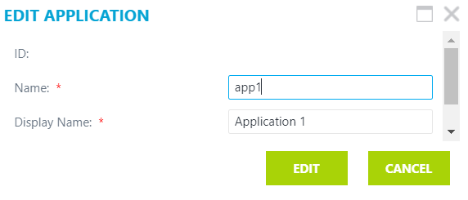

To delete, click on the application`s name you are interested in and click the Delete button. To refresh the list, click Refresh.

## Workdesks

Form for adding Workdesks.

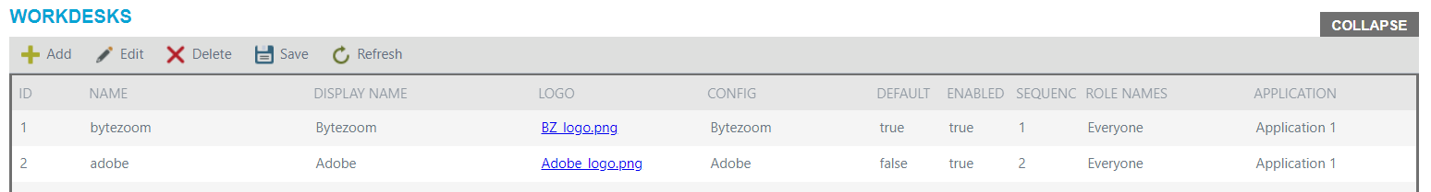

Buttons:

* Add
* Edit
* Delete
* Save
* Refresh

To add new workdesk click Add button. Add button opens a panel.

On the panel, you should enter the name and display name of workdesk. Choose the logo and config from ones, that you add on logos and configurations forms respectively. If you check Default checkbox, this workdesk will be open when you started our Wokdesk tool. If you check Enabled checkbox, this workdest will be available see. Then you should choose the sequence of workdesk in drop-down list, where workdesks would be shown. After, choose roles of users, who can see the workdesk, there are could be several roles. Select application, which will be set on this workdesk.

After adding, click Add button on panel and Save button on Workdesk form. To cancel changes click Cancel button on panel.

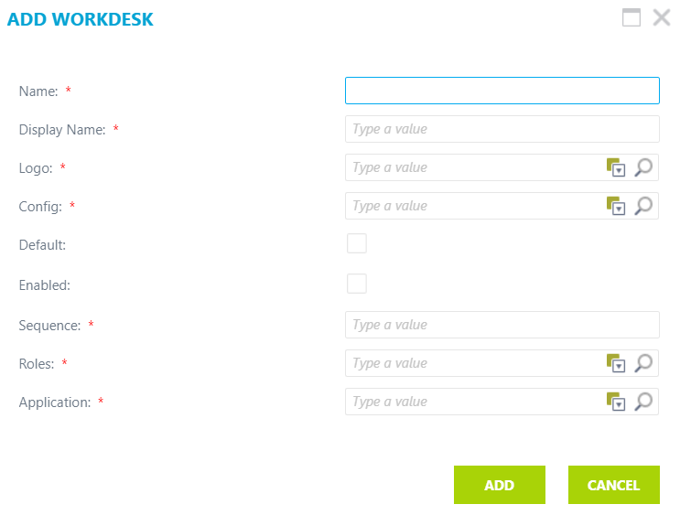

To modify workdesk click on workdesk you interested in and click Edit button. Edit button opens a panel, where you should make changes. After changes, click Edit button on the panel and Save button on the form. To cancel changes click Cancel button on panel.

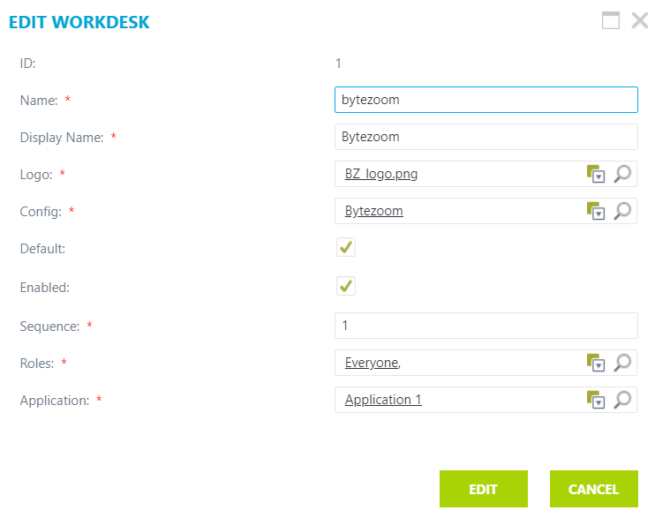

To delete, click on the workdesk you are interested in and click the Delete button. To refresh the list, click Refresh.

You can choose the wordesk in the drop-down list on the left side bar.

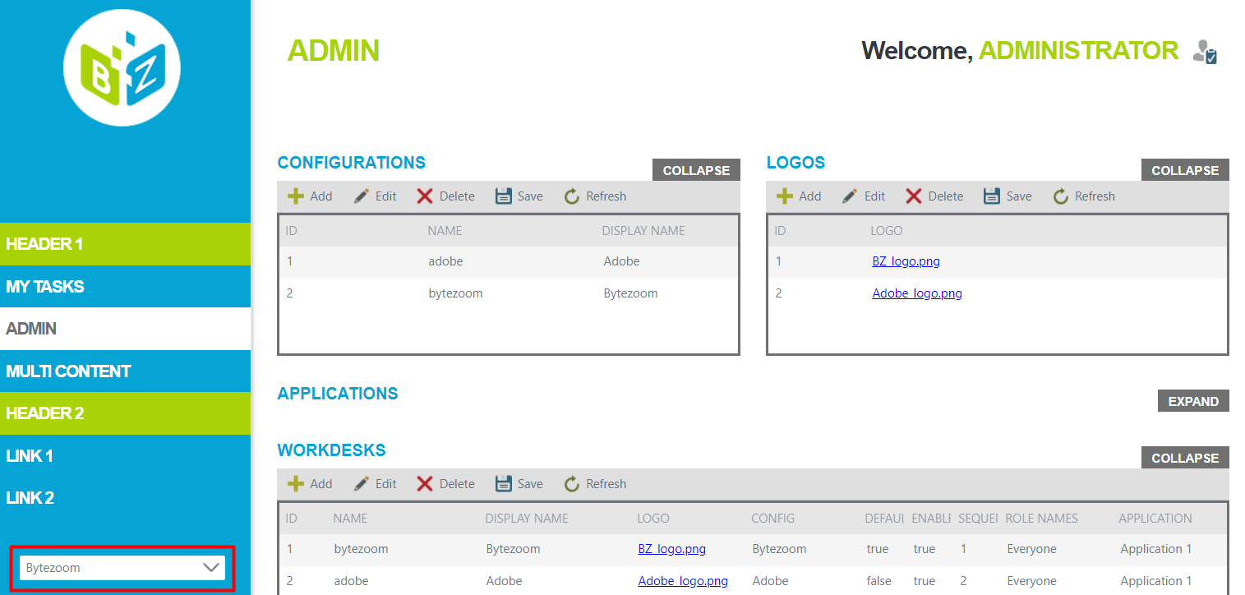

## Links

Form for adding links.

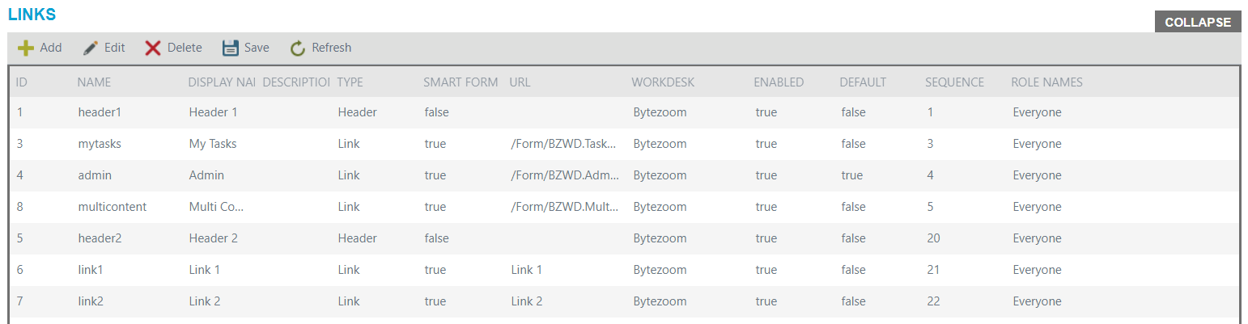

You can see that links are shown on the left side bar.

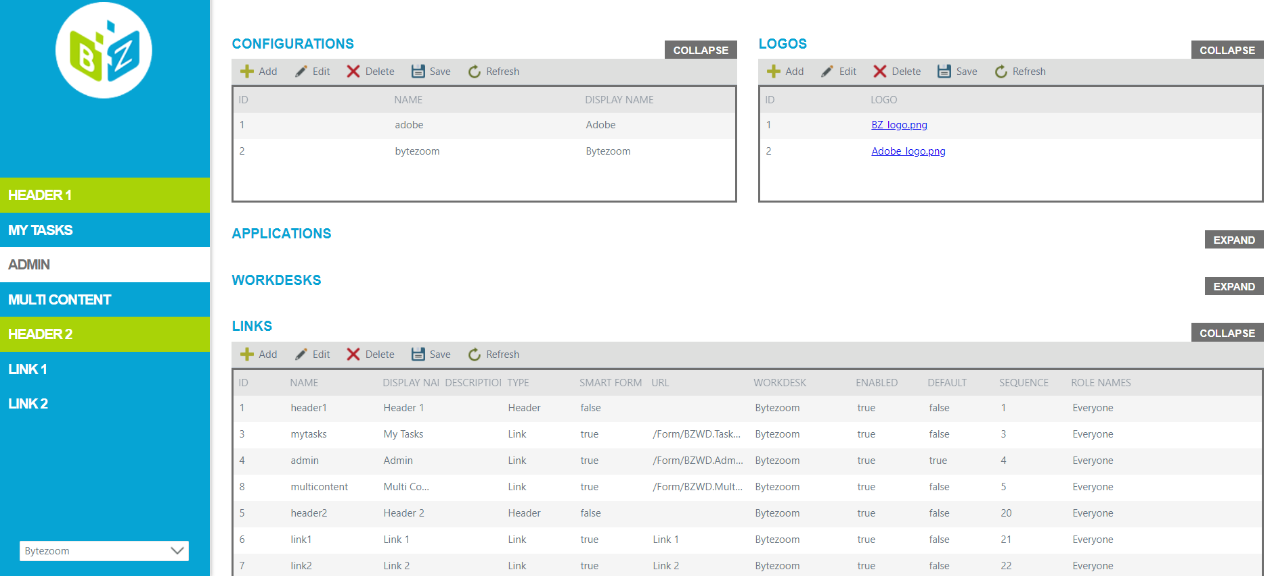

Buttons:

* Add
* Edit
* Delete
* Save
* Refresh

To add new link click Add button. Add button opens a panel.

Enter name and display name. Fill in the Description field if you need. Choose the type from the drop-down list, it could be list or header, note that header do not need the URL. If you do not choose the Smart Form checkbox, you should enter the whole URL address below, otherwise you need to enter only part of it, for example:

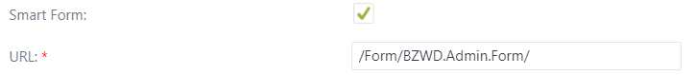

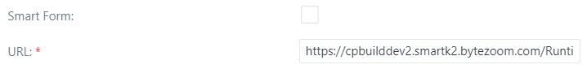

If you check Default checkbox, this link will be open, when you open the Wokdesk. If you check Enabled checkbox, this link will be available see. Then you should choose the sequence of link in left side bar. After, choose roles of users, who can see the link, there are could be several roles.

After adding, click Add button on panel and Save button on Links form. To cancel changes click Cancel button on panel.

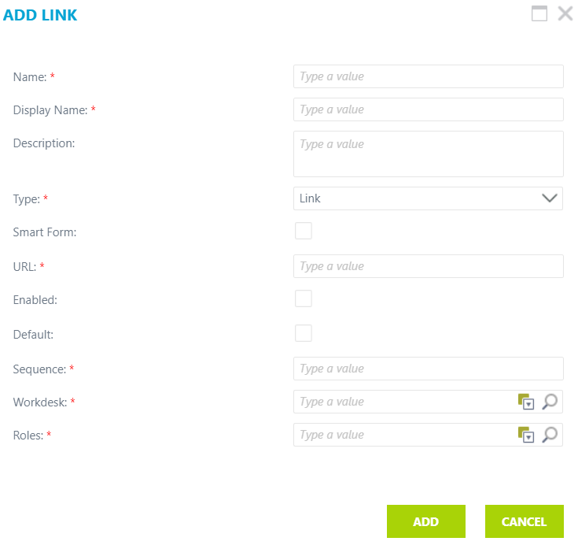

To modify link click on link you interested in and click Edit button. Edit button opens a panel, where you should make changes. After changes, click Edit button on the panel and Save button on the form. To cancel changes click Cancel button on panel.

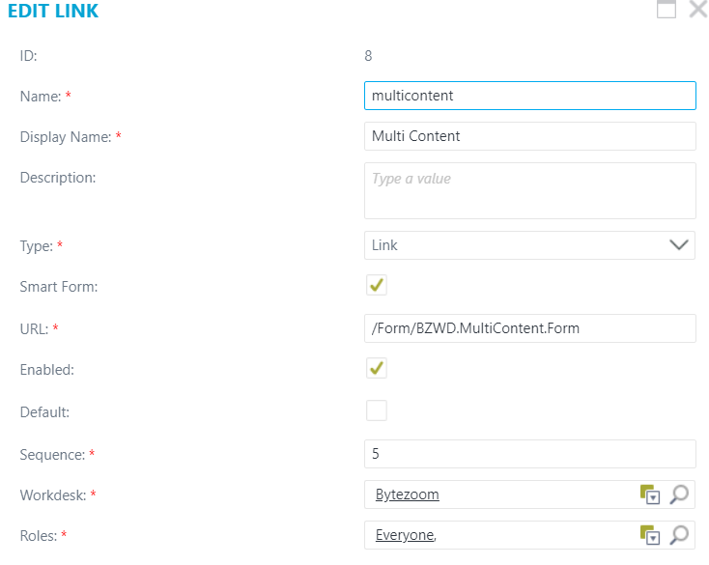

To delete, click on the link you are interested in and click the Delete button. To refresh the list, click Refresh.

## Roles

Form for assigning roles.

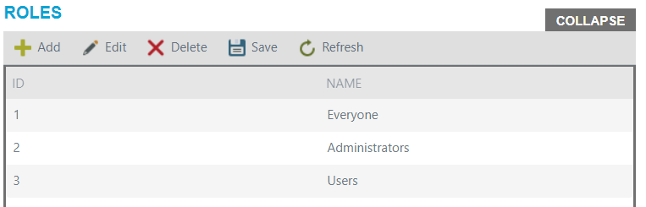

Buttons:

* Add
* Edit
* Delete
* Save
* Refresh

To add new role click Add button. Add button opens a panel, where you should enter the name of the role. After adding, click Add button on panel and Save button on Roles form. To cancel changes click Cancel button on panel.

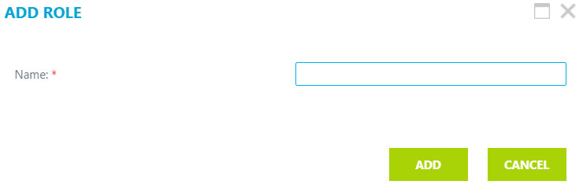

To modify role click on role name you interested in and click Edit button. Edit button opens a panel, where you should rename the role. After changes, click Edit button on the panel and Save button on the form. To cancel changes click Cancel button on panel.

To delete, click on the role you are interested in and click the Delete button. To refresh the list, click Refresh.

Note that users cannot edit or delete the same role they are.

## Roles members

Form for assigning members to a role.

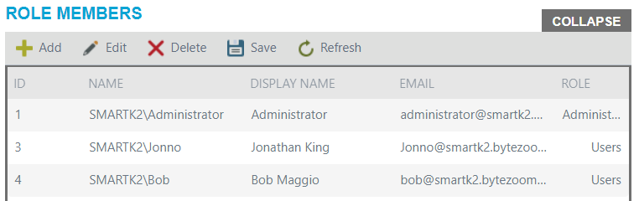

Buttons:

* Add
* Edit
* Delete
* Save
* Refresh

To add new role click Add button. Add button opens a panel, where you should enter display name, name, and email of the user, and assign him on of existing roles. After adding a role member, click Add button on panel and Save button on Role Member form. To cancel changes click Cancel button on panel.

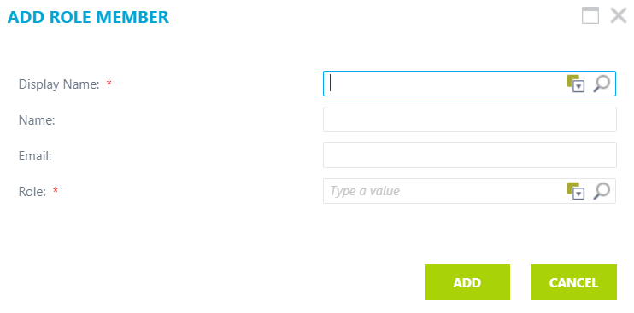

To modify role member information, click on role member you interested in and click Edit button. Edit button opens a panel, where you should make changes. After changes, click Edit button on the panel and Save button on the form. To cancel changes click Cancel button on panel.

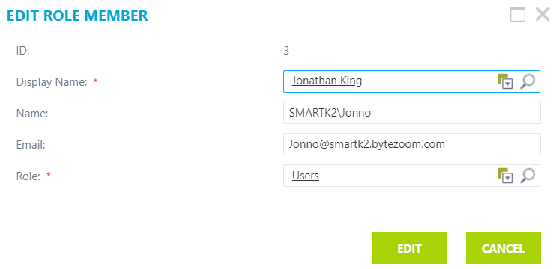

To delete, click on the role you are interested in and click the Delete button. To refresh the list, click Refresh.

Note that users cannot edit or delete themselves.